**CL118**

**Programming Fundamentals**

**Lab 02**

Pre-Programming phase

**Semester FALL 2020**

**NATIONAL UNIVERSITY OF COMPUTER AND EMERGING SCIENCES**

**LAB 02**

# Learning Objectives

This lab will cover the following topics:

* Introduction to flow chart
* Structuring a program by using flow charts
* Writing an algorithm

## Drawing the Program Flowcharts

* Flowchart is the graphic representations of the individual steps or actions to implement a particular module.
* The flowchart can be likened to the blueprint of a building. An architect draws a blueprint before beginning construction on a building, so the programmer draws a flowchart before writing a program.
* Flowchart is independent of any programming language.
* Flowchart is the logical design of a program.
* It is the basis from which the actual program code is developed.
* Flowchart serves as documentation for computer program.
* The flowchart must be drawn according to definite rules and utilizes standard symbols adopted internationally.

The International Organization for Standardization (IOS) was the symbols shown below (You can draw the symbols using ready-made flowcharting template):

**Flowchart** is a diagrammatic representation of sequence of logical steps of a program. Flowcharts use simple geometric shapes to depict processes and arrows to show relationships and process/data flow.

### Flowchart Symbols

Here is a chart for some of the common symbols used in drawing flowcharts.

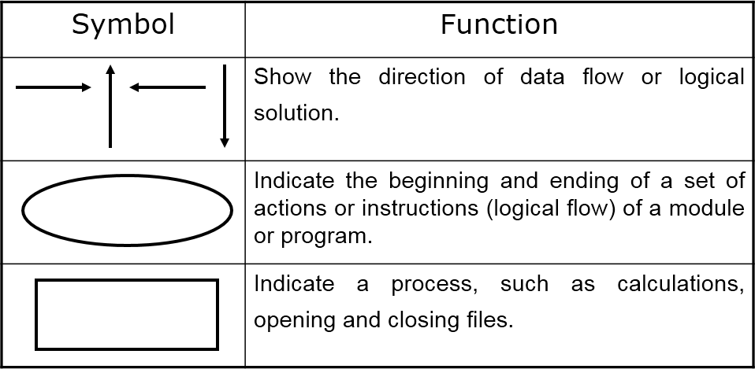

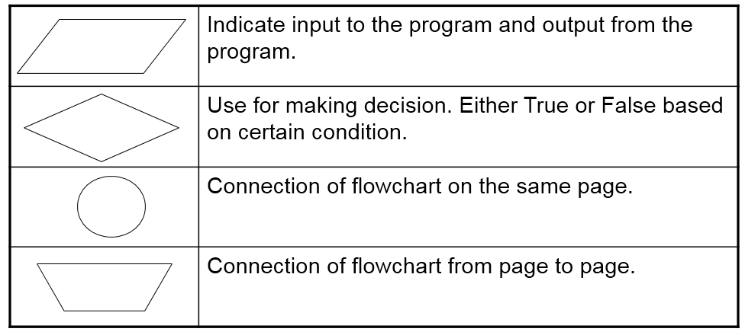

### Guidelines for Developing Flowcharts

These are some points to keep in mind while developing a flowchart −

* + Flowchart can have only one start and one stop symbol
  + On-page connectors are referenced using numbers
  + Off-page connectors are referenced using alphabets
  + General flow of processes is top to bottom or left to right
  + Arrows should not cross each other

### Example:

**Structuring a Program by using flow charts**

* 1. Use Modules
  2. Use four logic structures

### Sequential structure

* + - * Executes instructions one after another in a sequence.

### Decision structure

* + - * Branches to execute one of two possible sets of instructions.

### Loop structure

* + - * Executes set of instruction many times.

### Case structure

* + - * Executes one set of instructions out of several sets.
  1. Eliminate rewriting of identical process by using modules.
  2. Use techniques to improve readability including four logic structure, proper naming of variables, internal documentation and proper indentation.

1. **Sequential structure:**

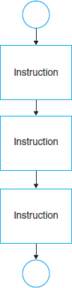

**Example:** Draw a flow chart that will allow the user to input 3 integers and have the sum calculated and outputted.

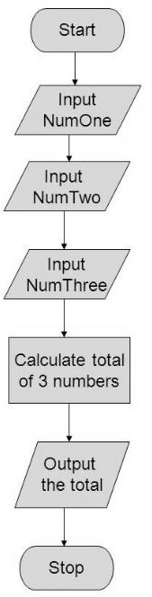

### Decision structure

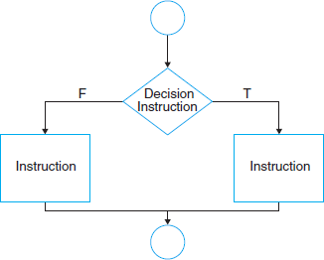

**Example:** Today it is raining! Draw a flow chart which ask about raining outside and take the decision of taking an umbrella with himself for going outside.

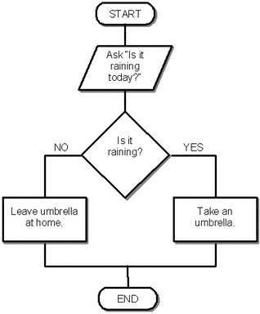

### Loop structure

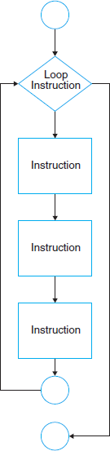

**Example:** Draw a flow chart that find the sum of five numbers.

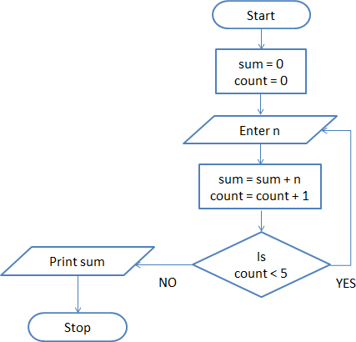

### Case structure

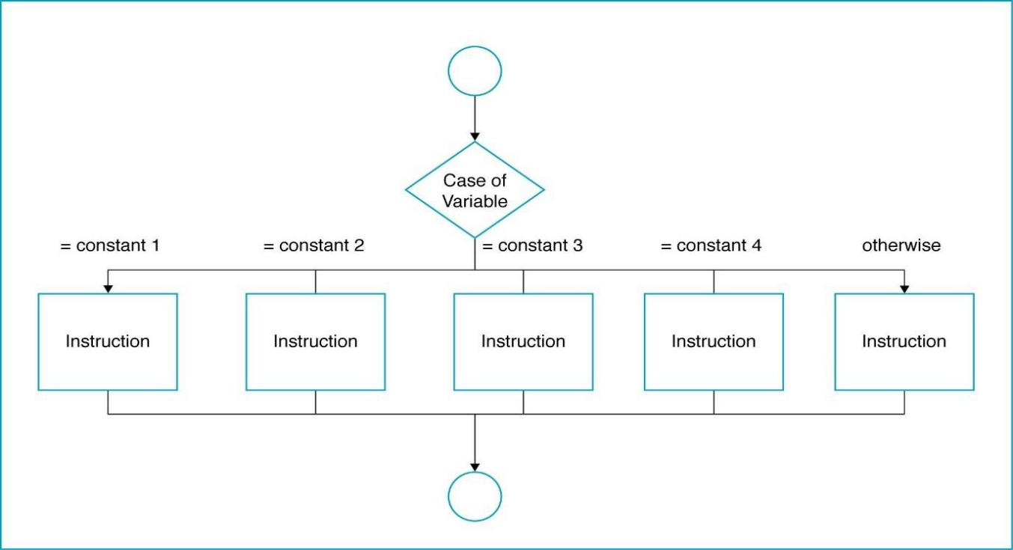

**Example:** Draw a conditional case structure flowchart of sales company for customer which shows the many country’s shipping time period like, the shipping to customers of USA country will be delivered in 2 days, for Canada will be 3 days and for others will be five days.

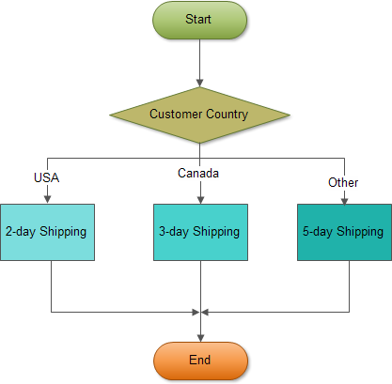

## Writing the Algorithm (Pseudo code)

* + - Pseudo code means an imitation computer code.
    - It is used in place of symbols or a flowchart to describe the logic of a program. Thus, it is a set of instructions (descriptive form) to describe the logic of a program.
    - Pseudo code is close to the actual programming language.
    - Using the Pseudo code, the programmer can start to write the actual code.

**Example:** write an algorithm and draw flowchart to “Buy a pen”

### Image result for algorithm and flowchart examplesAlgorithm:

**Step1:** Start

**Step2:** Go to stationary shop

**Step3:** Select a pen **Step4:** Pay the price **Step5:** Take the pen **Step6:** Come back home **Step7:** Stop

**Example:** find the sum of 5 numbers

### Algorithm:

**Step1:** Start

**Step2:** Initialize sum = 0 and count = 0 (PROCESS)

**Step2:** Enter n (I/O)

**Step3:** Find sum + n and assign it to sum and then increment count by 1 (PROCESS)

**Step4:** Is count < 5 (DECISION)

**Step5:** if YES go to step 2 else

Print sum (I/O)

**Step6:** Stop

# LAB TASK

## Task# 01:

Write an algorithm along with drawing a flowchart to find a number that whether it is even or odd.

**Task# 02**

Illustrate the following statement by drawing a flow chart. “A lamp in a room is not working, check if it is not plugged in, do plug it or check whether it might be burned out so replace it if not then repair it.”

**Task# 03**

Write an algorithm along with drawing a flowchart to find a largest number among three different numbers entered by user.

**Task# 04**

Draw a flow chart in which user input the number of month out of twelve months and get the name of semester in which the students are studying. For month ( 1 to 5) the semester is spring, for (6 and 7) month it is summer and for (8 to 12) month the semester is fall.

**Task# 05**

Write Algorithm & Flowchart to print multiplication Table of a number.

**Task# 06**

Write Algorithm & Flowchart to find if a number is prime or not.

**Task# 07**

Write an algorithm for a software program detects an input that is a serial [bit](https://www.sciencedirect.com/topics/engineering/bitstream) [stream](https://www.sciencedirect.com/topics/engineering/bitstream). The pattern to detect is a “101” sequence. When this sequence is detected, a light is turned on and the program stops. Also design its flow chart.